Budgetwise
Week 5 | 03/07/2026 - 03/13/2026

Leader: Casandra Marquez

Casandra Marquez  Time Spent  12 Hours | Tasks completed:  - Created weekly report, created Jira stories, and assigned tasks  - Merged Jonathan S’s branch for the settings page and added backend logic in settings.ts to update user information  - Added backend logic for income tracking so users can add either an expense or income with separate categories  - Merged MarceloMejia’s expenses fix  - Merged Sophia’s branch ai-features into front_back_merge  - Implemented a simple forgot password UI and added temporary backend logic to update a user’s password to the database until email verification is completed  - Merged Haru’s frontend UI for forgot password  Planned tasks for next week:  - Work on reset password through Gmail  - Look into integrating a banking system to add expenses  - Security, CI/CD, database optimization  Issues or challenges:  - Midterms  - Merging multiple branches into one cohesive app  - Integrating backend logic into frontend pages
Sophia Chau  Time Spent  11 Hours | Tasks Completed  - Updated project specs with color scheme and location of elements  - Researched what API to use for AI calls (can’t do OpenAI bc paid)  - Implemented 3 recommendations AI with API calls to test  Planned Tasks for Next Week  - Continue implementing AI features  - See if I can limit the amount of API calls to work under the limitations of a free account  Issues or Challenges  - AI recommendations are having a hard time differentiating between income and expenses (screenshot below). Anyone know why this might be happening?  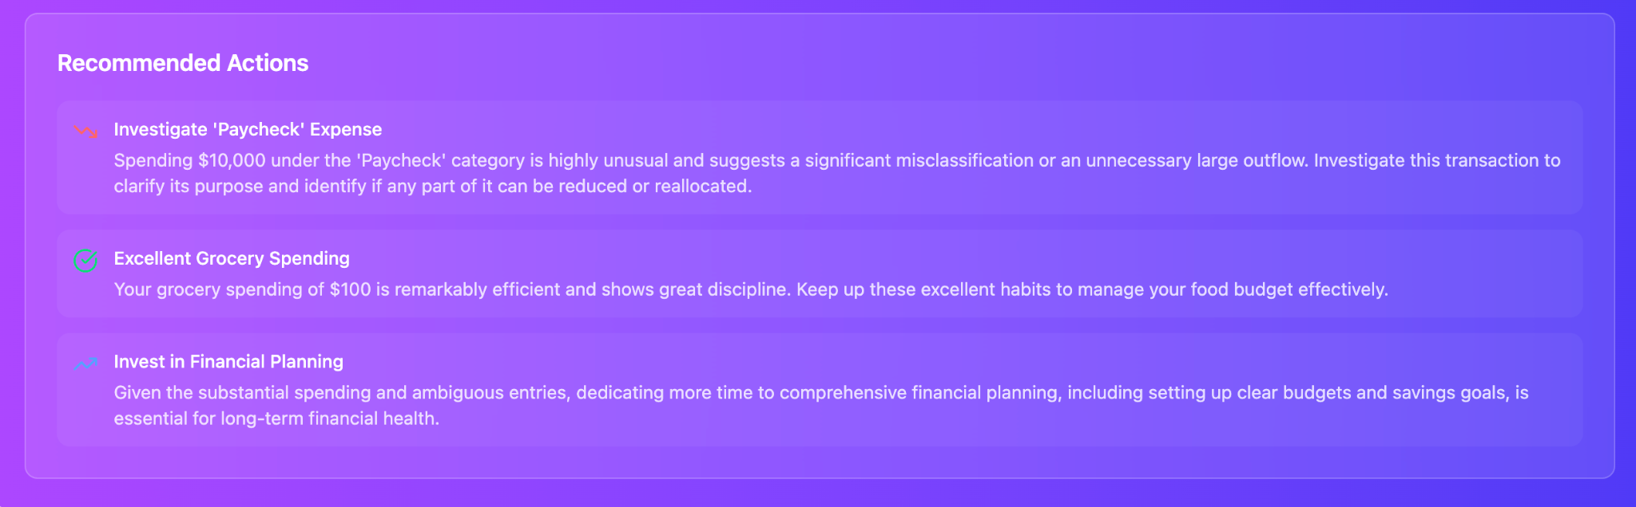  - Anticipated challenge = API calls are extremely limited for Gemini free version. I think we may need to limit our AI features for the future, as even testing only 1 time may exceed our limits for API calls. I will do more testing in the future to see what we can do as a workaround
Jonathan Gruber  Time Spent  20 hours | Tasks Completed  - Maintain architecture diagram  - Research how to send a password-reset email message to the email address of the user  Planned Tasks for Next Week  - Maintain architecture diagram  - Password-reset functionality, including, but not limited to  - Research how to send a password-reset email message to the email address of the user  Issues or Challenges  - Determining how to send a password-reset email message to the email address of the user
Marcelo  Mejia  Time Spent  7 hours | Tasks Completed  - The expenses page backend logic that allowed the user’s to add an income statement had been completed last week, so I added to the calendar page UI to show this.  - Added UI functionctionality allowing users to edit their income and expenses to a different amount, date, description, category, etc.  - Modified mock data to better fit the current scheme we have in the app, so that it can ported  personal_transactions_budgetwise_2025_2026.xlsx  - Edited some elements of the Dashboard to match what was being displayed in the expenses page and calendar  Planned Tasks for Next Week  - Last week I said I wanted to add a script /command for porting the mock data into the database upon startup (for testing purposes), but I wasn’t able to get to it.. This will probably be something I do next.  Issues or Challenges  - Completing the tasks for this week while having a lot of assignments and studying for midterm week.  - Sickness, not enough to stop working though.  - I had a small issue with prisma when I started working, but was able to get past it.
Jonathan Strong  Time Spent  12 hours | Tasks Completed  - The dashboard bar chart was only displaying a label for every other bar rather than for each bar so I removed it for now.  - The expense categories did not match up with the budget creator categories causing some issues with the pie and bar chart  - Changed it so that both expenses and budget creator had the same categories  - Created a basic settings page that displays currently signed in email and users name.  Planned Tasks for Next Week  - As more features are added update the settings page  - Work on any other portions needed  Issues or Challenges  - Tried to get the bar chart to display label for each category but could not figure it out  - Some slight issue with adding the new page but was able to add it successfully
Haru  Kimura  Time Spent  12 hrs | Tasks Completed  Implemented the forgot password frontend page UI with email input and reset request flow  Styled the page to match the existing login page design system (card layout, icons, gradient buttons)  Connected the Forgot Password link from the login page to the new page  Updated the auth provider route guard so the forgot-password and reset-password pages are accessible without authentication  Implemented the reset password page UI with password + confirm password validation  Added form validation for password mismatch and minimum length.  Added success and error UI states for the reset flow  Structured both pages so they can easily connect to the backend endpoints once the password reset email service is implemented  Planned Tasks for Next Week  Connect the forgot password form to the backend endpoint for sending reset emails  Connect the reset password form to the backend endpoint that verifies the reset token and updates the user's password  Continue refining UI consistency across authentication pages  Issues or Challenges  Needed to update the authentication route guard so the forgot-password and reset-password pages could be accessed without being logged in  - Juggling between midterms and this project

Total Time Spent: 74 hours

Summary:
Implemented income and expense tracking, editable transactions, dashboard and calendar updates, a settings page for updating user information, and initial forgot password and reset password flows. AI recommendation features were prototyped, multiple branches were merged into a unified application, and the frontend and backend were further integrated.

